Sustainable Supply Chain Performance(week1)

Step1:-open power BI and in Home we have “Get Data” option we click on that one.

-🡪to get the data we go to that option and there we have several options for “getting from”like csv,excel and etc. 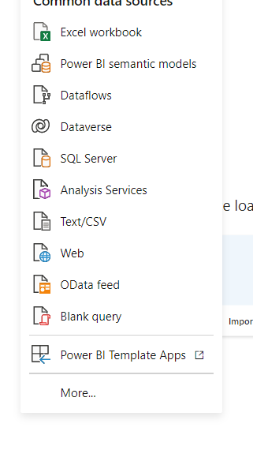

Step 2:-after getting the data from csv file from our storage ,there will open a new page with the table we selected with options on bottom as Load(After the data is cleaned new load the data),Transform data(for processing of data),cancel.We click on “Load” option.

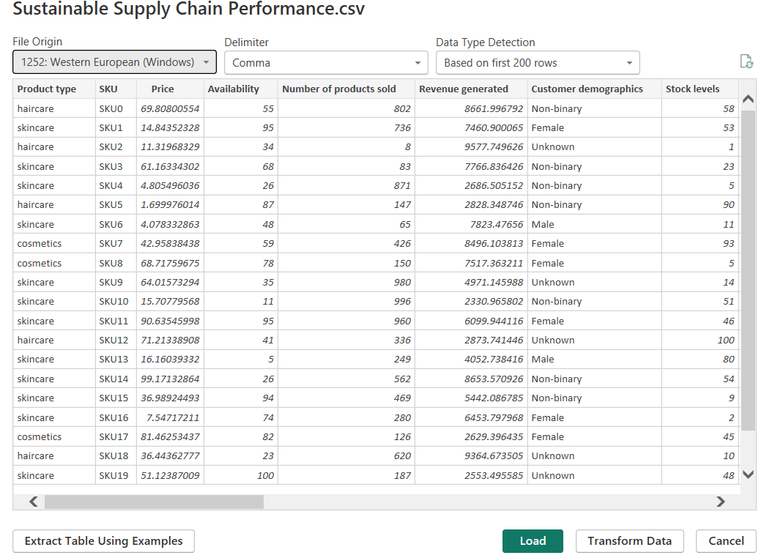

Step 3:- After loading the data we can see that our file is visible right side where we can see names of several columns.

Step 4:-we have three icons on the left hande side ,i.e1)Report View:-visualizations.2)Table View:-we can use it to view the data.3)Model View:-to work on multiple tables.

Step 5:-in home tab ,click on Transform data,a new page will appear that is power query editor.

Step 6:-Click on View tab and click in column quality ,then we will know if there is any errors are there or not .here in our data there are no errors in our data.We observe each column has their respective datatypes.

Step 7:-Next we duplicate the table.For that right click on csv file at right side there we will see duplicate option ,click on that and rename that duplicated table as Inventary.

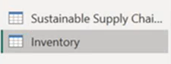 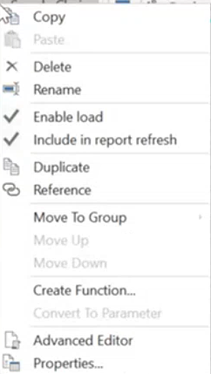

Step 8;_we can remove columns by right clicking on the column name delete.Here we created inventory column and put only those important columns as we know from the given data. 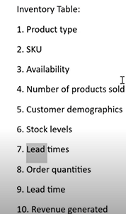Step 9:-like wise we create the duplicate of our original csv file and rename as Manufacturing table,supplier table chain table with columns.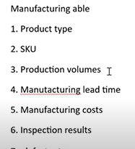

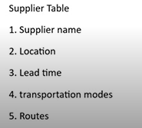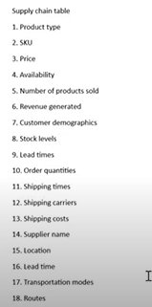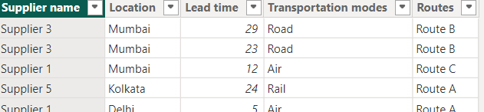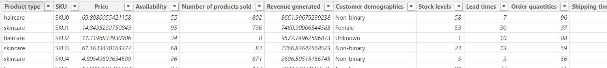

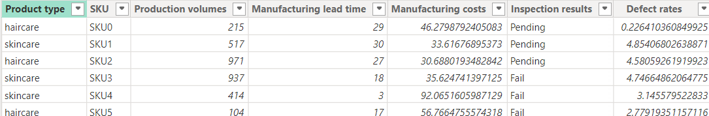

Step 10:-then we will click on Close and Apply for comminting the changes that we have done in our power bi then we will get our table names as :-

